Ball Valve
Operation Manual
1. Scope
This manual covers ball valves with nominal sizes DN15 mm to DN500 mm (1/2" to 20") and nominal pressures PN1.6 MPa to PN10 MPa (ANSI Class 150 to 600), with threaded, flanged, butt-welded, and socket-welded connections, for manual, gear-operated, electric, and pneumatic operation, in both 2-piece (split-body) and 3-piece (jacketed-body) designs, in both floating-ball and trunnion-ball configurations.
2. Purpose
2.1 This ball valve is primarily used for opening and closing the medium in pipelines and equipment.
2.2 Valve body material shall be selected based on the medium:
2.2.1 Carbon steel valves -- suitable for water, steam, and oil media.
2.2.2 Stainless steel valves -- suitable for corrosive media.
2.3 Applicable temperature ranges depend on seat material:
PTFE (polytetrafluoroethylene) -- max. 130 C
PTFE (polytetrafluoroethylene) + fiberglass -- max. 160 C
PPL (polyphenylene) -- max. 300 C
3. Structure
3.1 The basic structure of the ball valve is shown in Figure 1.
3.2 Wear-resistant gaskets and packing use PTFE or flexible graphite, providing reliable sealing.
4. Operation
4.1 Manual valves are operated by a handle or gear assembly. Electric or pneumatic ball valves are driven by the electric or pneumatic actuator, rotating the ball 90 degrees to open or close the valve.
4.2 The stem of manual ball valves has a groove at the top. When the groove is aligned with the flow direction and the wrench length direction matches the flow, the valve is OPEN. When the groove is perpendicular to the flow direction, the valve is CLOSED.
4.3 For electric and pneumatic ball valves, open and close positions are indicated by the position indicator on the electric or pneumatic actuator.
5. Storage, Maintenance, Installation, and Use
5.1 Valves shall be stored indoors in a dry and ventilated area. Both pipeline openings shall be sealed.
5.2 Valves stored long-term shall be inspected periodically; remove debris. Pay special attention to keeping the sealing faces clean to prevent damage.
5.3 Before installation, verify that the valve markings match the service requirements.
5.4 Before installation, inspect the valve bore and sealing faces; if any contaminants are present, wipe clean with a soft cloth.
5.5 Before installation, check that the packing is compressed. Ensure the packing maintains its sealing function while not obstructing stem rotation.
5.6 During system or pipeline pressure testing after installation, the valve shall be in the fully open position.
5.7 Operate the ball valve with the ball either fully open or fully closed. Do not use the ball in a partially open position for flow regulation.
5.8 For manual valves, open and close using the handle directly. Do not use auxiliary levers or other tools.
5.9 Valves in service shall be inspected periodically. Check the sealing faces, gaskets, and packing for wear and damage. If any components are damaged or worn, repair or replace them promptly.
5.10 For the storage, maintenance, installation, and use of electric and pneumatic valve actuators, refer to the "Valve Electric Actuator Manual" and "Valve Pneumatic Actuator Manual".
6. Possible Faults, Causes, and Resolutions -- See Table 1
Table 1 Possible Faults, Causes, and Resolutions
Possible Fault | Cause | Resolution
Packing leakage | 1. Packing gland not tightened  2. Packing has failed due to prolonged use or improper storage | 1. Tighten nuts evenly to compress packing  2. Replace packing
Leakage between sealing faces | 1. Sealing face contaminated with foreign matter  2. Sealing face damaged | 1. Clean foreign matter from sealing faces  2. Re-machine / repair or replace
Leakage at body-bonnet joint | 1. Joint bolts tightened unevenly  2. Flange sealing face damaged  3. Gasket fractured or failed | 1. Tighten bolts evenly  2. Re-machine the flange face  3. Replace gasket
Handwheel difficult to rotate / ball fails to open or close | 1. Packing compressed too tightly  2. Packing gland / compression assembly misaligned | 1. Slightly loosen packing gland nuts  2. Re-align packing gland assembly
Electric / pneumatic actuator fault | See "Valve Electric Actuator Manual" and "Valve Pneumatic Actuator Manual"
7. Warranty
The manufacturer provides warranty for valves placed into service for up to one (1) year from start of use, but no longer than eighteen (18) months from date of shipment. During the warranty period, any failures attributable to product quality will be repaired or have parts replaced at no charge.

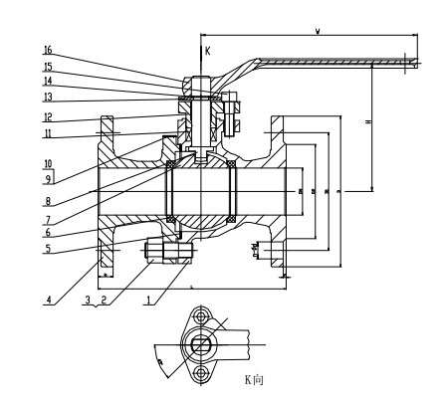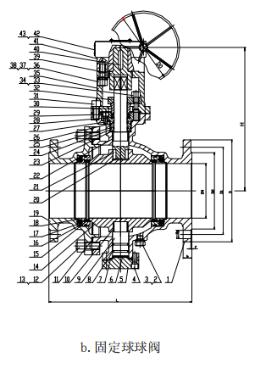
a. Floating-Ball Ball Valve b. Trunnion-Ball Ball Valve


WEIZIDOM GROUP
www.wsdvalves.com
South City, Longhu Town, Xinzheng City,
Zhengzhou City, Henan Province, China

